5 G- Stretch

The G- Stretch Tool, has not been updated by Loop tools yet to work with the new version of the annotation and G pencil tools. Until this update is done it will be impossible to finish this tutorial at this time.

# What is G Stretch?

G Stretch is a bit different than some of the other tools. Mainly because it does take an extra preparatory step before we can work with it.

We can begin by adding a plane in Object mode through the top view. So, that it can appear to be laying flat on the floor.

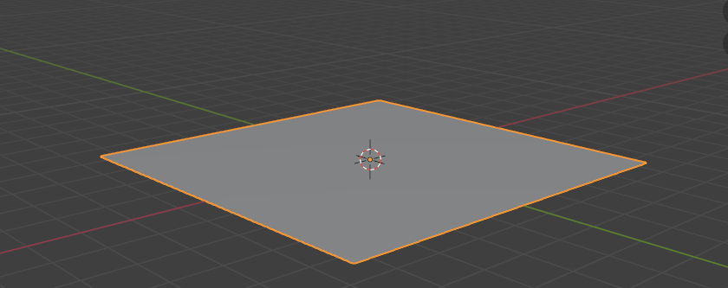

Then, with our plane we can subdivide it in Edit mode and add a few of the bumps and dips in it as we did before with flatten. I added 10 cuts.

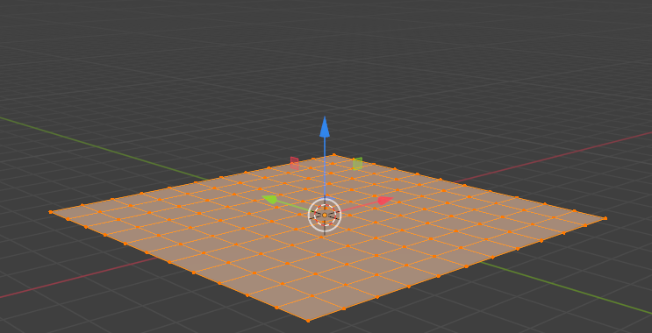

# Setting the Tool to Either Annotation or G Pencil

Ok, now here is where things get a bit different. Hit the N key to open up the tools at the right side of the panel. The thing is what we want is not in tool tab for this side panel, even though what we are trying to get to is a tool.

When you first open the Tools options by hitting the N key, you will come to this Item dialog box by default. We do not want **Item**, what we want to hit the Edit tab

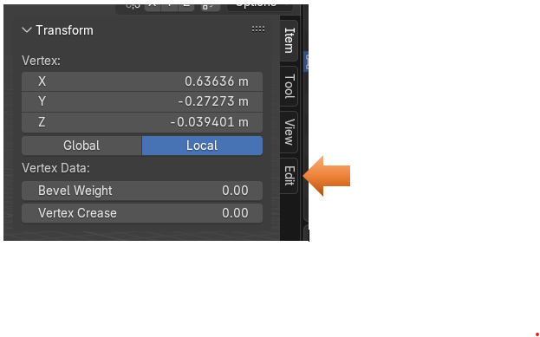

When you hit the Edit tab you will see this little piece of text at the top of the viewport that says Loop Tools.

*Of course, you will only see any of this stuff if you have enabled your Loop Tools in the Preference section of Blender. We have gone over how to do this several times in previous tutorials on the Loop Tools.

But for now, we are here, and we need to open that arrow that points to Loop Tools on the screen.

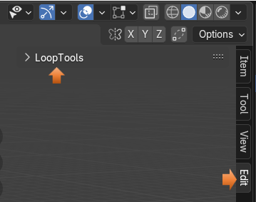

You might have to widen this dialog box a bit to see the full text that describes the section that we are looking for. We need the section that says Use Guides. You will find that by default, it will say None. In order for this G-stretch to work, we need this to be set to either Annotation or G Pencil. Either one will work, it just can’t be set to none, or nothing is going to happen.

We will be using what we draw out as a guide line for our curve.

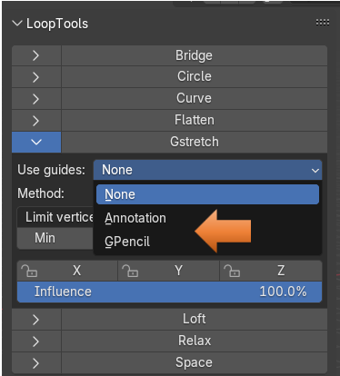

I’m going to choose the Option for Annotation here.

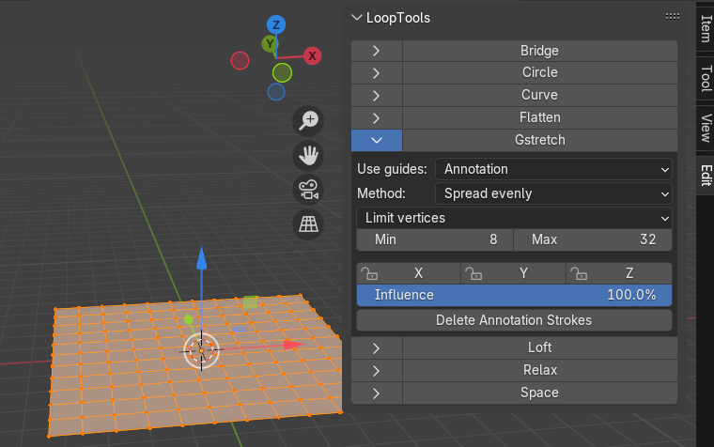

# Annotation Tool

Now we want to select the Annotation Tool from the Tool box. This tool is like a pencil and you can use it to either write text or draw something on the screen. We just want to draw out the curve that we want our edge loop to follow.

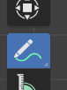

With the tool selected you can just draw out a curve on the screen. I am in top view and my plane is flat on the ground. This way I can easily have access to my edge.

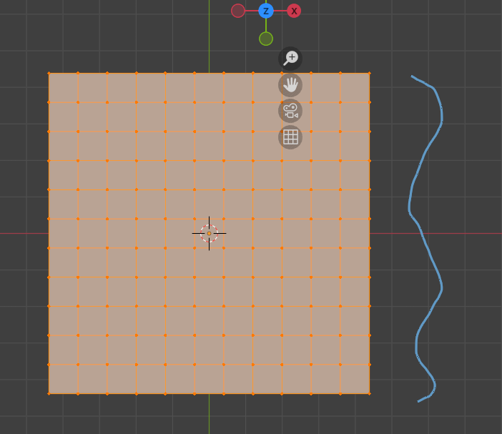

Now take your box selection tool and select all of the vertices on the edge next to the curve you just drew.

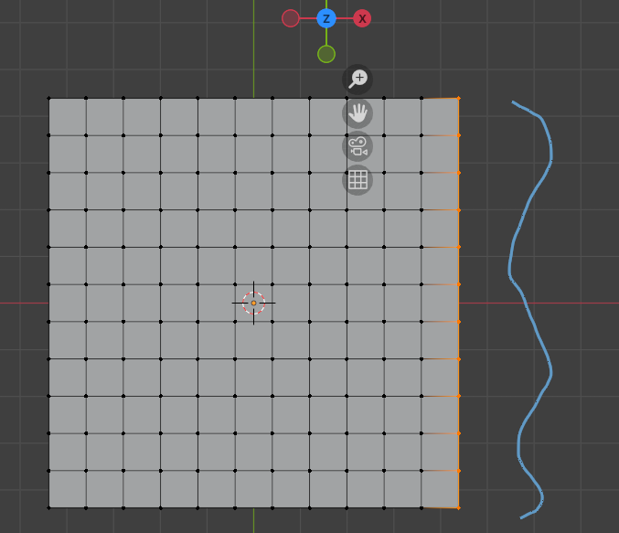

You can hit the G stretch here and use it like a button to run the tool. Remember when you have your panel open using the N button, you can get to your Loop Tools by hitting Edit tab at the right of the dialog box.

